**AGI MONITORING UI**

Contents

Introduction 3

Project Structure 4

❖ Page structure 4

❖ Data Flow 5

▪ Dashboard 5

▪ New Tab 6

▪ Application 7

▪ User / Company 8

Components 9

Features 9

Configurations 20

Deployment 21

# Introduction

This React application is a user interface for monitoring and controlling the AGI system. This monitoring system is used to view, and check the status of ZAU applications. It provides functionalities to different categories of users: User, Admin, and Super Admin, with Super Admin being the highest level of access. Users and Admins belong to a company, whereas Super Admins have overarching control. Each Admins able to Add, Delete and modify ZAU application belong to the Company. Users can only view the ZAU apps. The main dashboard displays a comprehensive view of all applications within the system, providing critical insights and controls.

# Usage (How to Use the dashboard)

* Super admin can login to the System Dashboard after application deployment using default username and password.

Default User Name :- Zaion-SA

Default Password :- Zaion-SA

* Super admin can change their default user name and password.
* After, A company should be created. Only Super admin can create the
* Then, Admins and Users can be created under the Super admin company.
* Also, Super admin can create ZAU applications belonging to selected company.
* Each Admins can log into the system and they can control everything belonging to their company. Admin can add more users and other admins to their company. Also admin can create company owned applications.
* Each user can only monitor and view ZAU applications and other information belonging to their company.

# Project Structure

## Page structure

* First login to the application by using the username and password.
* Then by using dashboard open the dash board cards.
* 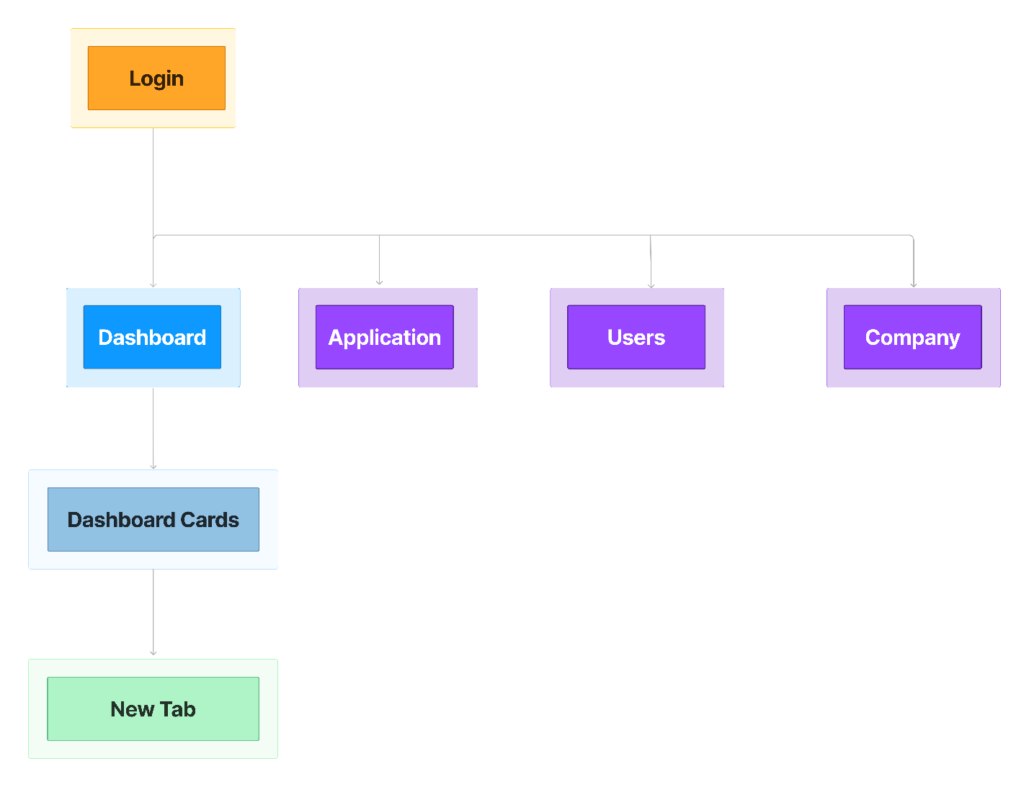Open a New Tab.

## Data Flow

### Dashboard

### New Tab

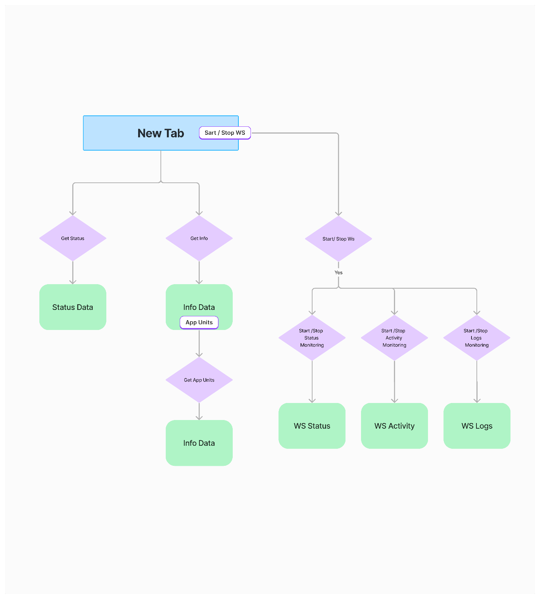

### Application

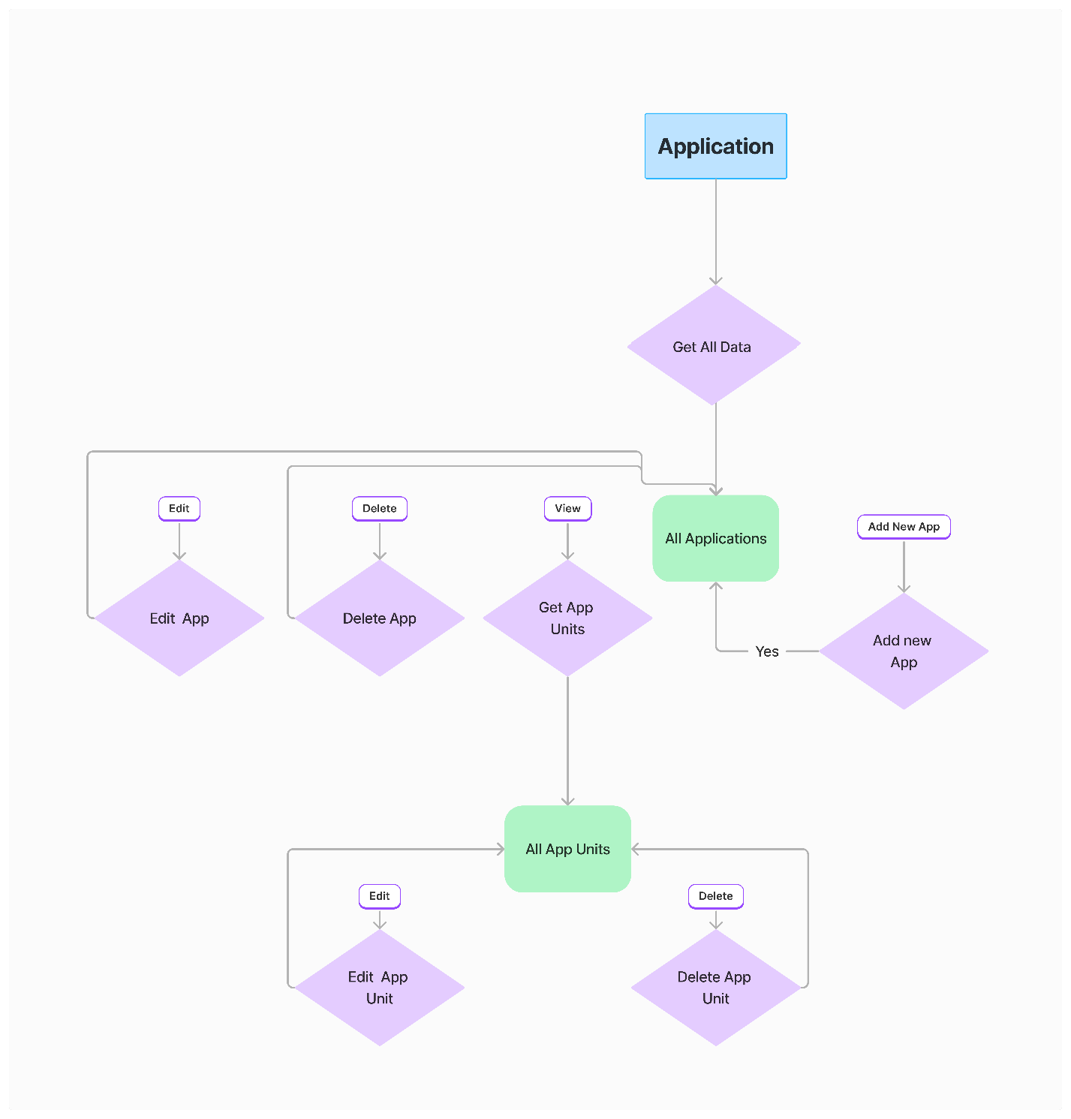

### User / Company

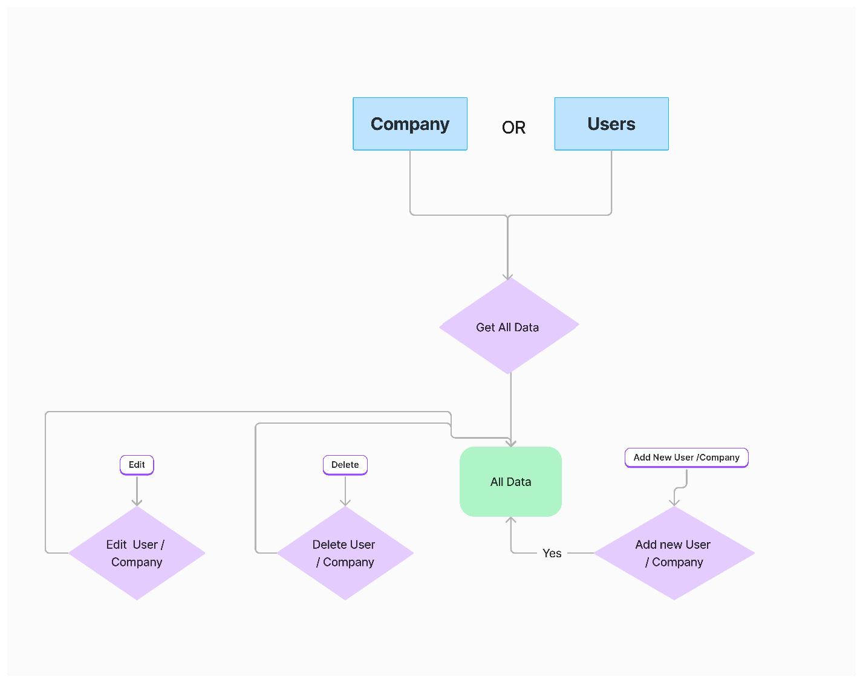

# Components

**Monitoring_ui/**

├── public/

├── src/

│ ├── assets/

│ ├── components/

│ │ ├── Header.js

│ │ ├── Footer.js

│ │ ├── DashboardCard.js

│ │ ├── Header.js

│ │ ├── Sidebar.js

│ ├── pages/

│ │ ├── Login.js

│ │ ├── Dashboard.js

│ │ ├── Application.js

│ │ ├── User.js

│ │ ├── Company.js

│ │ ├── NewTabComponent.js

│ ├── context/

│ │ ├── ThemeContext.js

│ │ ├── UserContext.js

│ ├── routes/

│ │ ├── Router.tsx

│ │ ├── ProtectedRoute.tsx

│ ├── services /

│ │ ├── ApiService.js

│ │ ├── AuthService.js

│ ├── config/

│ │ ├── config.js

│ ├── utils/

│ ├── App.js

│ ├── main.tsx

│ ├── Router.tsx

│ ├── ProtectedRouter.tsx

├── package.json

├── Dockerfile

├── DockerCompose.yml

├── .env

└── README.md

# Features

**Login**

* + - A screenshot of a computer screen

      Description automatically generatedUser can login given username and password. Login component protected using private routers.

**Dashboard**

* + - Display all the ZAU applications in the Dashboard.
    - Display application information and current status whether it is running or not.
    - Also user can manually Refresh and get latest data and if its not running modify the configurations.
    - A screenshot of a computer

      Description automatically generatedUsing view button, user can see the all the information of each application. When clicking view button it will open as a new browser tab.
    - A screenshot of a computer

      Description automatically generatedEach Application Open as a new Tab and Display and monitoring real time Status, Activity and Logs data.
    - 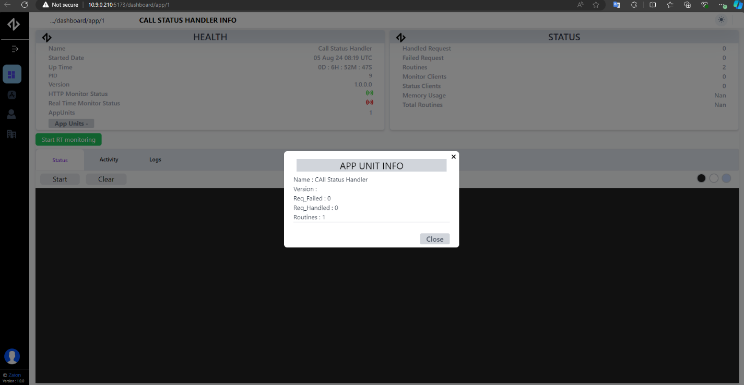Using App Units button, able to see all the application units data.
    - 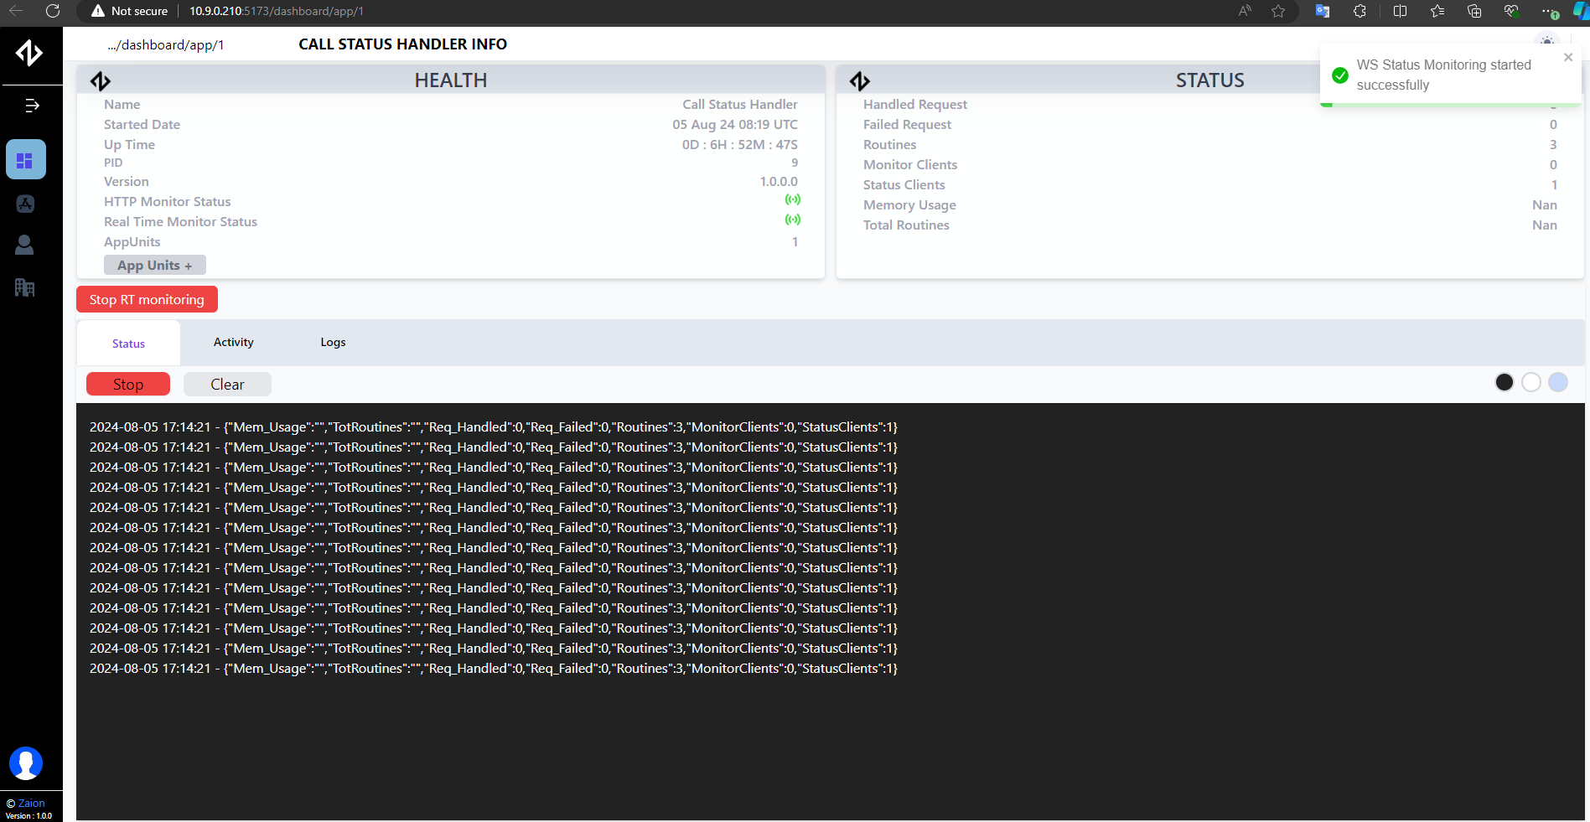Using the Start RT Monitoring button, real-time monitoring can be started. Users can see all statuses, activities, and logs in real-time. When the start button on each section is clicked, the real-time data will be displayed below.

**Applications**

* + - 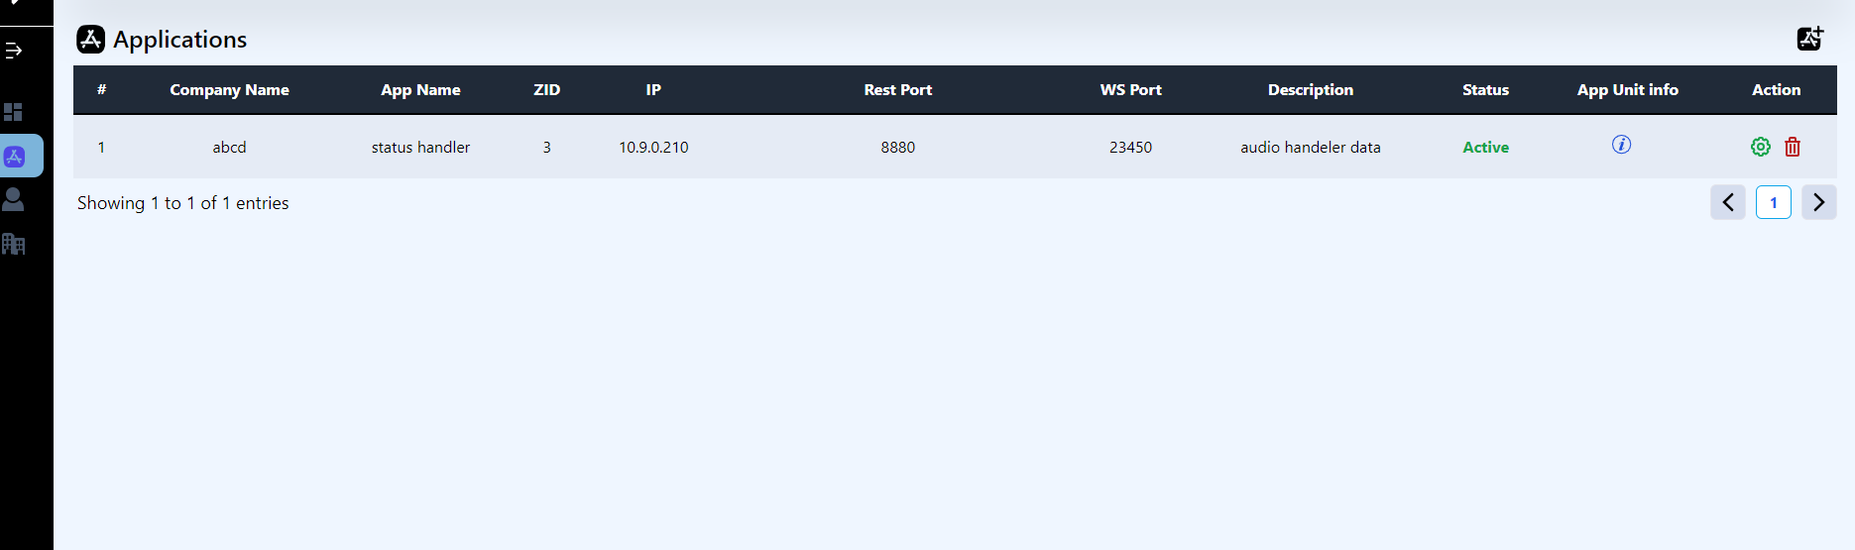Display all the applications
* Add new application.

* User should provide application data and ZAU app Unit data. ZAU app unit should upload as a zip file and inside should be expected file structure. Zip file name and .so file name should be equal.

Example:-

**audiohandeler.zip**

**│**

**│ ├── Config /**

**│ │ ├── config.json**

**│ ├── audiohandeler.so**

* + - Edit application data.

* + - Delete application.

**App Units**

* + - View all ZAU App Units data

* + - Add ZAU App Unit data.

Here also ZAU should provide correct file structure of application data

* + - Edit ZAU App Unit Data.

There are two options. User can change only ZAU app data or user can change all the ZAU app data. Then also ZAU should provide correct file structure of application data.

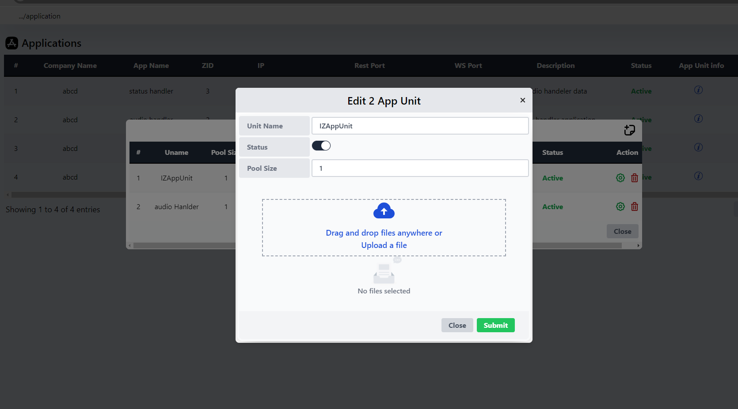

* + - 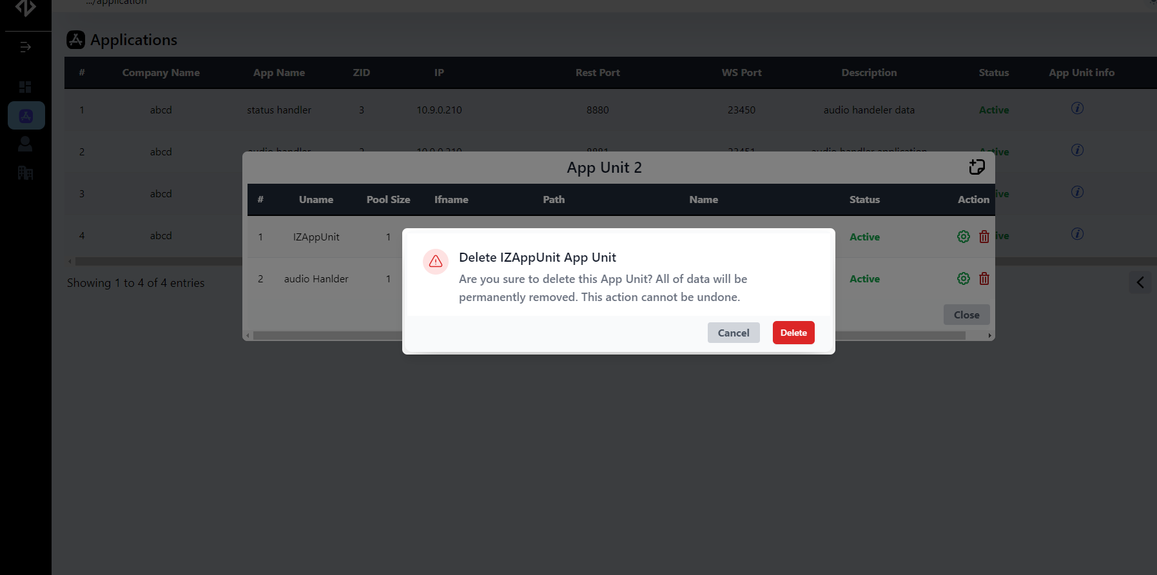Delete ZAU App Unit.

**User**

* + - Display all the Users. (Super-Admin, Admins, Users)
    - There are mainly 3 User TypesA screenshot of a computer

      Description automatically generated. Super-admin, Admin and Users. Super-Admin can view and control all admins and users. Admins can see that users and other administrators belong to the company. Admin can control each user. Users can only view admins and users belonging to the company.
    - Add User.

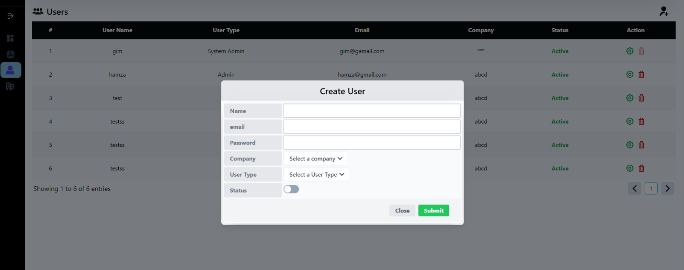

* + - 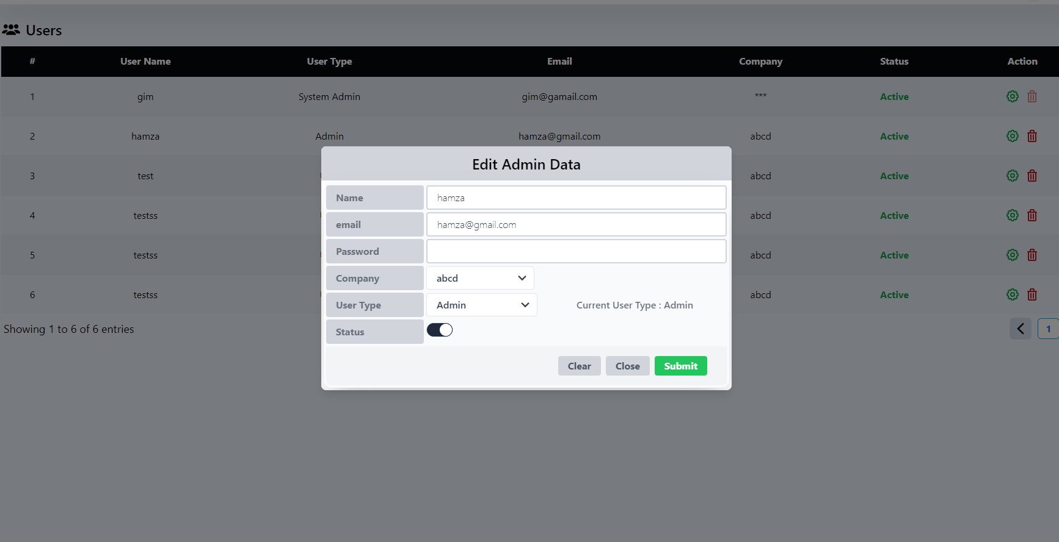Edit User data
    - Delete Users.

**Company**

* + - 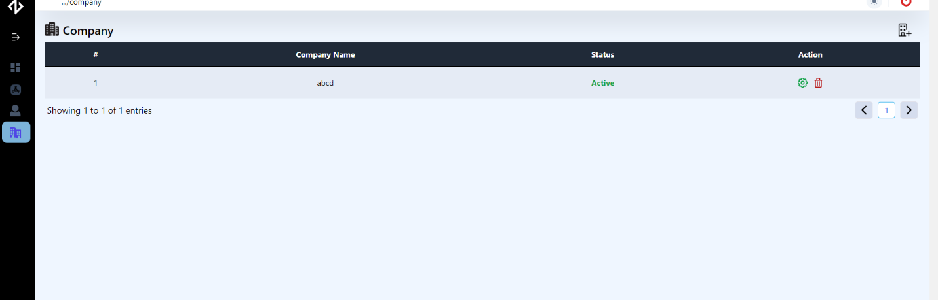Display all the Company.
    - A screenshot of a computer

      Description automatically generatedAdd Company. Only Super-admin can add new companies to the system. Also super-admin can delete or Modify the company data.
    - A screenshot of a computer

      Description automatically generatedEdit Company data.
    - 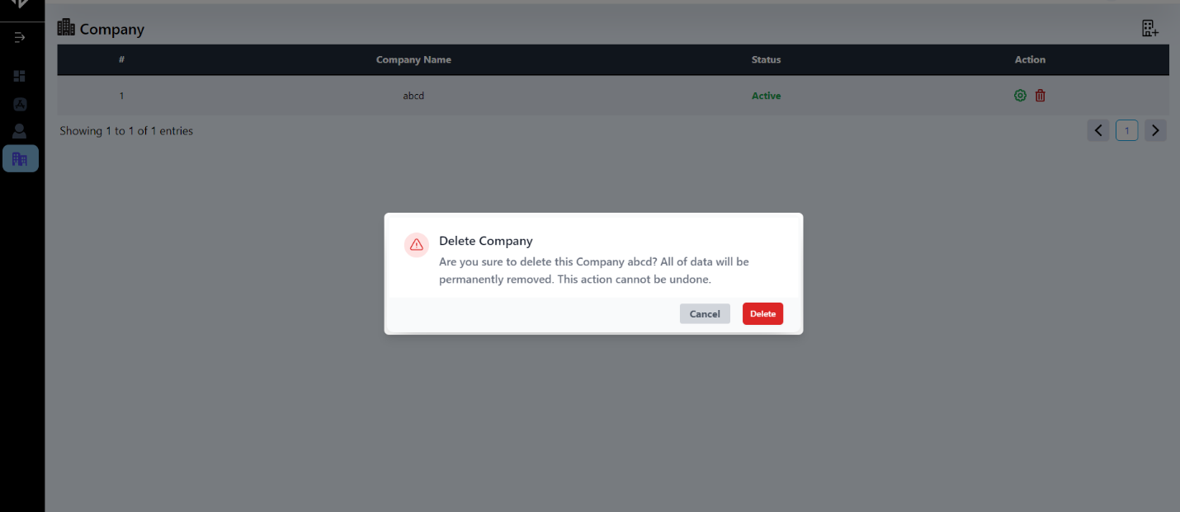Delete Company.

# Configurations

REACT_APP_CLIENT_SERVER_IP=127.0.0.1

REACT_APP_CLIENT_PROTOCOL=http

REACT_APP_CLIENT_PORT=5173

REACT_APP_SERVER_SERVER_IP=127.0.0.1

REACT_APP_SERVER_PROTOCOL=http

REACT_APP_SERVER_PORT=8000

UI_TIME_OUT = 3 * 60 * 1000

REACT_APP_RETRY_COUNT=0

REACT_APP_MAX_RETRIES=3

REACT_APP_RETRY_DELAY=1000

# Build & Deployment

Using the npm run build command, we can build locally and deploy it to the server as a Docker container, or we can create a Dockerfile to build and deploy the automatically.

Build the release locally and copy the build folder to the server. Then execute below commands.

docker build -t ag-monitoring-ui .

docker run -d -p 5173:80 --name zaion-monitoring-ui ag-monitoring-ui

or

Execute command using Docker-compose file. Then execute this commands.

docker-compose build -d

docker-compose up

K.G.L.G.Dayananda